# Universiti Tunku Abdul Rahman

**UECS3383 Software Quality Assurance**

#### Assignment

**Helpdesk Support Management System**

**&**

**Software Change Control Management**

**___________________________________________________________________**

|  |  |  |
| --- | --- | --- |
| **ID** | **Student Name** | **Email** |
| 1807254 | Low Meng Horng | menghornglow99@gmail.com |
| 1703185 | Tan Andy | dydytan@1utar.my |
| 1703648 | Tan Ying Yao | yyaoutar@1utar.my |
| 1701231 | Lim Thien Chung | thienchung@1utar.my |
| 1704368 | Wong Yin Khye | stevenwong0121@1utar.my |

|  |  |  |  |
| --- | --- | --- | --- |
| **Q No** | **Total Marks** | **Marks** | **Total** |
| Part A1 | 50 marks |  |  |
| Part A2 | 50 marks |  |
| Part B1 | 50 marks |  |  |
| Part B2 | 50 marks |  |

# TABLE OF CONTENTS

# Part A1

# ACTIVITY FLOW OF HELPDESK SUPPORT MANAGEMENT SYSTEM 4

# Part A2

# OVERVIEW OF PROJECT MANAGEMENT ACTIVITIES 7

# Part B1

# DEPLOYMENT PROCESS FLOW 11

# INCIDENT MANAGEMENT 12

# PROBLEM MANAGEMENT 21

# CHANGE MANAGEMENT 28

# INCIDENT MANAGEMENT FORM TEMPLATE 34

# PROBLEM MANAGEMENT FORM TEMPLATE 37

# CHANGE MANAGEMENT FORM TEMPLATE 39

# Part B2

# BUG FIXES HANDLING WORKFLOW 41

# TESTING HANDLING WORKFLOW 46

# SOFTWARE RELEASE HANDLING WORKFLOW 49

# LESSON LEARNT WORKFLOW 51

# BUG FIXES HANDLING FORM TEMPLATE 53

# TESTING HANDLING FORM TEMPLATE 55

# SOFTWARE RELEASE HANDLING FORM TEMPLATE 57

# LESSON LEARNT FORM TEMPLATE 59

# REFERENCE DOCUMENT 60

**Part A: (100 marks)**

Assuming you have been promoted to the new role of Helpdesk Support Manager for the Software House. There are various on-going projects in the organization; the clients community groups are spread over the South-East Asia countries (i.e. Thailand, Singapore, Vietnam, Indonesia, Philipines, Cambodia, Myanmar, Laos and Brunei). The company is managing all the client calls and feedback via the centralized Helpdesk Support Management Systems (HSMS). In the Year 2020, the helpdesk support services achieved 69% of the Client Satisfaction Index (CSI); where the company target of helpdesk support services is 85% annually.

As a newly promoted Helpdesk Support Manager, you are required to look into CSI rating seriously.

You are required to perform the following task and present to the management for feedback and

recommendation:

A1. Provide a broad overview of activities flow between the Helpdesk Support Management Systems and the Software Development Team; particularly manage the entire life cycle of a ticket (until ticket closure) (50 marks)

Note: You are required to place the numbering of EACH activities

A2. Provide a broad overview of project management activities flow to take over the management of “software change control” from the helpdesk management support team. (50 marks)

Followings are series of project activities (not in chronological sequence), you are required to place the correct activities in the relevant phase(s) of PLC versus SDLC as per provided tabular template in the example section.

A1

|  | Customer | HSMS | Helpdesk Support Staff | Helpdesk Manager | Software Development Manager | Technical Team |
| --- | --- | --- | --- | --- | --- | --- |
| **Incident Management**  **20 marks** | 5. HSMS will generate a response  with the solution to reply | 1. Customer attempt to send an email/phone/web form to the HSMS portal  8. HSMS give response on gratitude and ask to fill in the customer satisfaction index survey  YES  Solution worked  6. Customer attempt to solve the issue and reply to the incoming response  3. HSMS will assign the ticket based on the category and priority level to the HSS  2. Based on the details that the customer submitted, HSMS will categorize the incident by analyzing the priority level and creates a ticket reference number | 7. The ticket along with customer’s feedback is returned to HSS  No  7. HSMS close the ticket and update the ticket status to solved  4. HSS will pick the solution script for the given issue and put into the ticket | 8. HSS create a new issue with details to let HM to evaluate  1  YES  No  Issue Solutions | 9. HM evaluate the issue and provide details on the issue to the SDM |  |
| **Problem Management**  **10 marks** |  |  | 15. HSS update the ticket status and attach the solution into the ticket on the HSMS | 14. SDM evaluate the solution and forward the solution to the HSS | 13. SDM approve the solution and forward the solution to the HM | 10. Technical Team receive the detailed report on the issues from the SDM  11. Technical Team analyze the root cause and attempt to think the solution  Issue Solutions  12. Technical Team formulate a solution for SDM  1  No  Yes |
| **Change Management**  **20 marks** | 2 |  |  | No  23. HM plan a User Acceptance Test for the customer  Yes | 19. SDM feedback to the technical on changes that cannot be made  18. SDM review the request and evaluate the severity of the problem is worth for the changes  Yes  Approve changes  23. HM gives feedback on the report and ask for resubmission from the Technical Team  No  Report Approval  22. HM review the report | 16. Technical Team attempt to make changes to solve the issue  1  17. Technical Team submit a request with the changes that they want to make  19. SDM inform the Technical Team to proceed and make changes in scheduled time  20. Technical team perform software testing after changes is made  1  21. Technical Team evaluate the test result and make correction  No  Test Pass  21. Technical Team document the changes made and file a report to HM to plan a User Acceptance Test  Yes |
| **Change Management**  Yes  24. User Conduct the User Acceptance Test and the Result is evaluated by the Technical Team  2  **20 marks**  31. Customer receive and automated response regarding the closing of ticket and summary of issue that is solved.  31. HSS update the ticket status on the HSMS and close the ticket. A detailed patch note is also being kept on the HSMS  30. HM view the report and ask the HSS to do a summary on things that is changed and updated  29. SDM compiled a report to HN on the things that is approved  28. Technical Team give a status update to SDM once the production is released and the changed note is compiled.  27. Technical Team receive instruction from HM to put the changes into the current system for production release  26. SDM receive the summary of the User Acceptance Test report  No  25. Technical Team check the Test Result  Test Pass | | | | | | |

**A2**

|  |  |  |  |  |  |  |
| --- | --- | --- | --- | --- | --- | --- |
| **PLC**  **VS**  **SDLC** | **Software Change Control Management: Project Life Cycle (PLC) Activities** | | | | | |
|  | **Initiation** | **Planning** | **Execution** | **Monitoring & Control** | **Project Closure** |
| **Software Change Control Maaement: System Development Life Cycle (SDLC) Activities** | **Planning** | (1) **Business Case sign-off**  (2) **Charter Sign-off** | (3) **Transform items in BC to CR Form**  (7) **Develop WBS**  (8) **Develop Project Schedule** |  | (11) **Review and Approve Unit Test Plan, System Test Plan, Integration Test Plan, UAT Plan** |  |
| **Analysis** |  | (4) **Perform Analysis on CR Form** |  | (6) **Review and Approve CR Form**  (13) **Review and Approve Unit Test, System Test, Integration Test**  (15) **Code Walkthrough**  (23) **Conduct Conformance Audit**  (24) **IQA Audit**  (25) **Annual Audit** |  |
| **Design** |  | (5) **Perform Design Analysis on CR Form**  (9) **Develop Unit Test Plan, System Test Plan, Integration Test Plan, UAT Plan** | (10) **Design and Develop Prototype** |  |  |
| **Implementation** |  |  | (12) **Fill Test Form**  (14) **Retest failed Test Form**  (16) **Check-in source code** | (17**) UAT Sign-off**  (18) **Prepare Software Release Note**  (19) **Approve Software Release Note** |  |
| **Maintenance** |  |  |  | (20) **Bugs Fixing**  (21) **Send email notification on Patch release**  (22) **Helpdesk Management System take over**  **after Patch release** |  |

**Part B (100 marks)**

**Part B1: Helpdesk Support Management Plan (50 marks)**

Develop a customer support quality management plan for the IT Software House. Using the information from Part A, you are required to perform **tracking, monitoring and reviewing** the followings project activities:

1. **Helpdesk Support Quality Manual** with the combination of workflow, process flow, policy, standard, guideline, procedure and work instructions for the following project activities: **(40 marks)**

* Incident Management ( 4 x workflows and relevant documentations*)
* Problem Management ( 3 x workflows and relevant documentations*)
* Change Management ( 2 x workflows and relevant documentations*)

1. **Forms template** related to Part B1: **(10 marks)**
   1. Incident Management (3 x Comprehensive Forms)
   2. Problem Management (2 x Comprehensive Form)
   3. Change Management (2 x Comprehensive Form)

**Part B2: Software Change Control Quality Plan (50 marks)**

Develop a software change control plan for the IT Software House. Using the information from Part A, you are required to perform **tracking, monitoring and reviewing** of tickets received from the helpdesk support management system:

1. **Software Change Control Quality Manual** with the combination of workflow, process flow, policy, standard, guideline, procedure and work instructions for the following project activities: **(40 marks)**

* Bug Fixes Handling ( 4 x workflows and relevant documentations*)
* Testing Handling ( 2 x workflows and relevant documentations*)
* Software Release Handling ( 1 x workflows and relevant documentations*)
* Lesson Learnt ( 1 x workflow and relevant documentations*)

1. **Forms template** related to Part B1: **(10 marks)**
2. Bug Fixes Handling ( 2 x Comprehensive Forms)
3. Testing Handling ( 2 x Comprehensive Form)
4. Software Release Handling ( 2 x Comprehensive Form)
5. Lesson Learnt ( 1 x Comprehensive Form)

* Denotes any combination of process flow, policy, standard, guideline, procedure and work instructions

**[STARTS YOUR REPORT HERE]**

**Part B1 A)**

**DEPLOYMENT PROCESS FLOW**

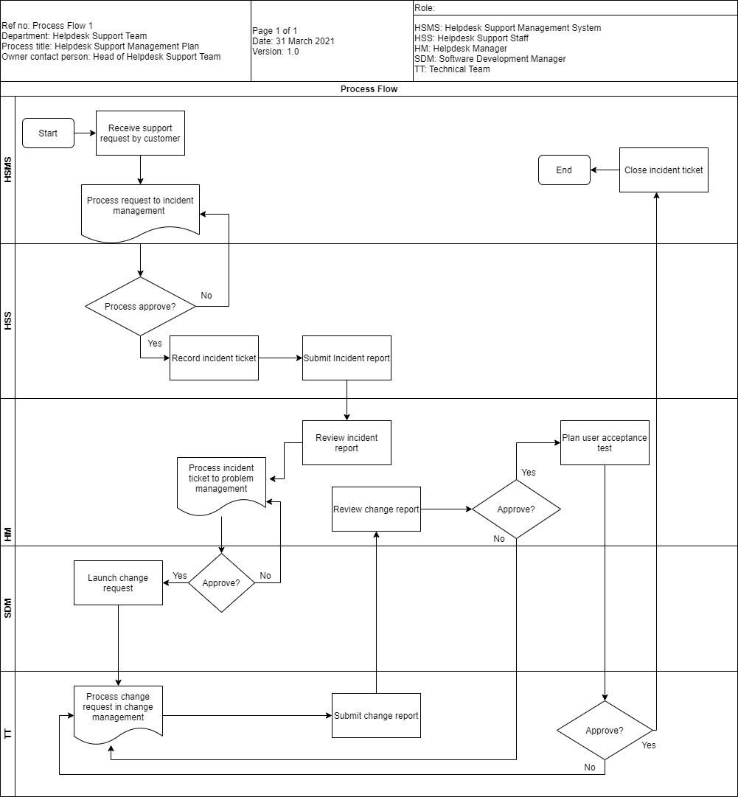

1. **Incident Management**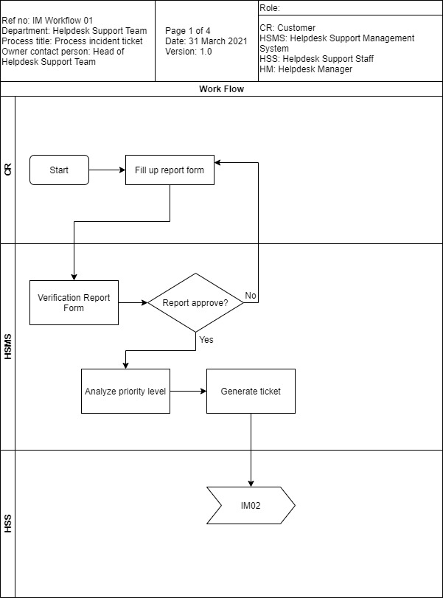

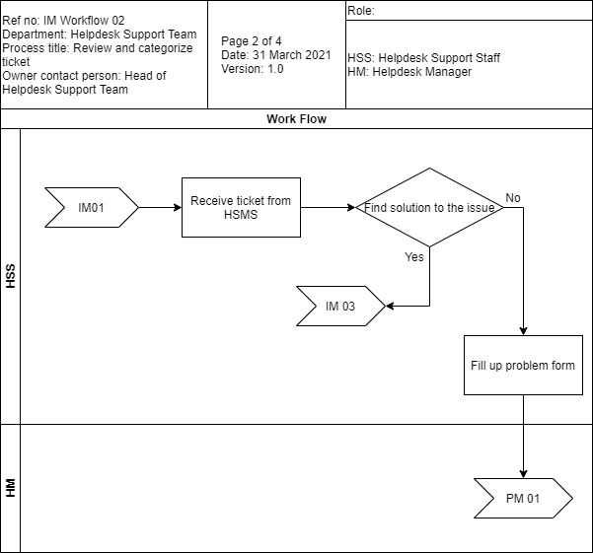

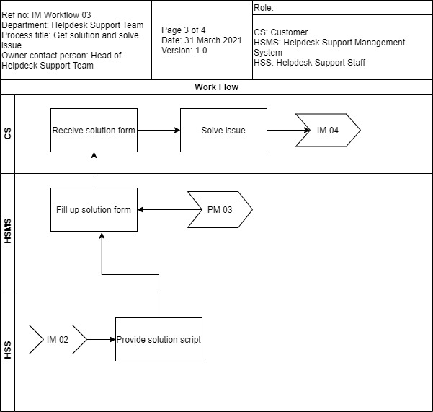

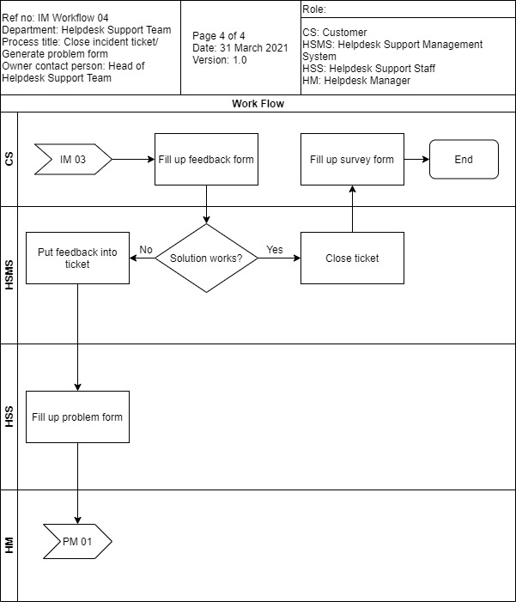

Policy

|  |  |  |  |
| --- | --- | --- | --- |
| **Software Company Name** | | | |
| Policy Title: **Incident Management Policy** | | | |
| Policy Number: IMP-v001 | Rev No: 0 | Effective Date: 1 Jan 2022 | Page No:1 of 1 |

1. Purpose

The purpose of the incident management policy is to plan for, respond and manage the incident occurred in a timely manner and to be more systematic, which included Critical, Normal and Less Critical level. The purpose included below:

* Respond to and resolve the ticket that raised by the clients as soon as possible.
* Communicate with the clients in an appropriate way.
* Manage the reputation of the company by providing high quality help desk support services.

1. Scope

This policy is applied to:

* All of the clients that subscribed, pre-ordered, purchased any software product of the company.
* All clients that possessed either default or customized software product of the company.
* Any category individual or group that keen to the company products.

1. Reporting

Enquiry and ticket should be raised to the hotline, 1300-88-2525 or through email to [abc.company@support.com](mailto:abc.company@support.com) as soon as any bug or defect discovered to prevent any serious consequence to the clients’ company, ideally within 6 hours. The ticket raised must include all of the clients’ details followed by any 3rd party details.

|  |  |  |  |
| --- | --- | --- | --- |
| Urgency level | Business/ Financial Exposure | Description/ Work Outage | Respond and Resolution Time |
| 1. Critical | High exposure of business and financial. | * The system of the client is totally loss of service. * Some important service is not working at all. * Clients are not able to carry out business-related function of the system. | Within 4 hours. |
| 1. Normal | Normal exposure of business and financial. | * The system is working but some of the non-business-related functions are not working. * External or sub system is not working properly. | Within 12 hours. |
| 1. Less Critical | Low exposure of business and financial | * Data showing and rendering issue. * Spelling and grammar mistakes of the system. * Error that not affecting the business-related experience. | Within 1 day. |

1. Response
2. Responsibilities
   * Clients is responsible to provide feedback and report all of the incidents to the help desk support team.
   * Help desk support staff is responsible to record down the incident into the incident form.
3. Policy
   1. The contact of the clients must be recorded down into the system.
   2. The incident progress and resolution must be recorded into the incident management form.
   3. Each of the incident will be assigned with different level of severity.
   4. Every incident management form must be reviewed by the superior of the help desk support staff.

Standard

|  |  |  |  |
| --- | --- | --- | --- |
| **Software Company Name** | | | |
| Standard Title: **Incident Management Standard** | | | |
| Standard Number: IMS-v001 | Rev No: 0 | Effective Date: 1 Jan 2022 | Page No:1 of 1 |

This standard describes the prerequisite for dealing any incident faced by the help desk support staffs with the standards stated below:

* The help desk staffs must have a manual which contains all of the information with severity level, priority of the incidents.
* Help desk staff is responsible to notify help desk support manager if found out that the incident could not be solved by the approaches that stated in the manual.
* Help desk support manager must notify software development manager about the incident that reporting specific defect of the system.
* Help desk support staff is responsible to prepare an incident report after the incident is solved.

Guideline

|  |  |  |  |
| --- | --- | --- | --- |
| **Software Company Name** | | | |
| Guideline Title: **Incident Management Guideline** | | | |
| Guideline Number: IMG-v001 | Rev No: 0 | Effective Date: 1 Jan 2022 | Page No:1 of 1 |

1. Receive the phone calls or emails from the clients which regarding to the software product and the system.
2. Respond to the phone calls within 15 seconds and email within 1 minute.
3. Raise the ticket into the system with its priority level.
4. Refer to the help desk support manual to check whether there are any workarounds.
   1. If the workarounds are found, help desk support staff has to reply to the clients, ideally within 5 to 10 minutes.
   2. If the workarounds are not found, help desk support staff has to report to the help desk support manager.
5. After the problem is solved, the staff has to ask the clients to rate the service satisfactory.
6. Lastly, the staff has to close the ticket raised after entering the satisfactory level int the system.

Work instructions

|  |  |  |  |
| --- | --- | --- | --- |
| **Software Company Name** | | | |
| Work Instruction Title: **Incident Management Work Instruction** | | | |
| Work Instruction Number: IMWI-v001 | Rev No: 0 | Effective Date: 1 Jan 2022 | Page No:1 of 1 |

1. Response – Help desk staffs are required to reply the clients in the time specified with the way client contact the help desk.
2. Ticket raising – Whenever the clients call in, all of the incident happened no matter critical or not, must be complete an incident form immediately.
3. Priority analysis – The priority level can be referred from the help desk manual and to be classified into the priority level stated.
4. Incident-problem transfer – Problem form will be created when the manual doesn’t have the solution in the help desk manual.
5. Service rating – The rating will be done after the incident faced has been solved.
6. Ticket closing – When all of the procedures are done, with the agreement from the client, the ticket will be closed from the system with the status of completed.
7. Problem Management

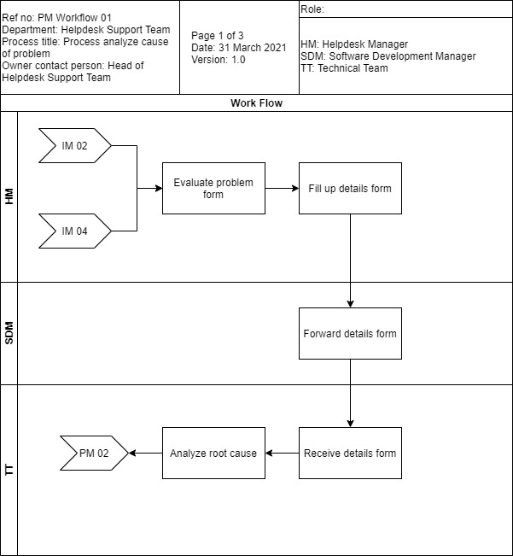

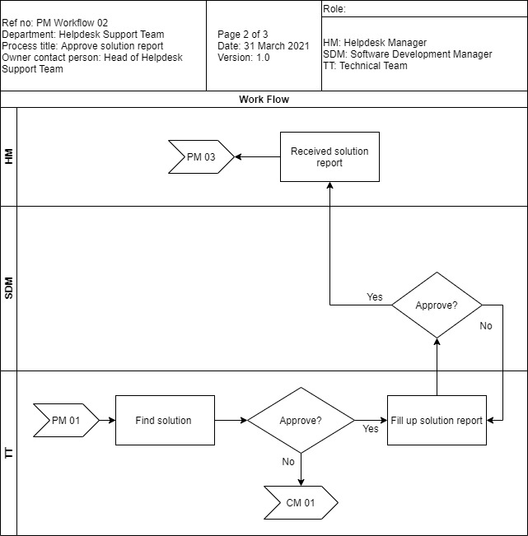

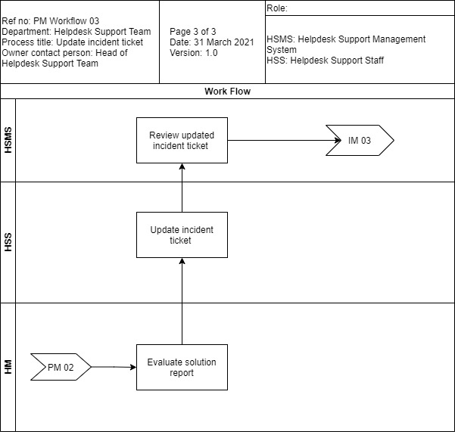

Policy

|  |  |  |  |
| --- | --- | --- | --- |
| **Software Company Name** | | | |
| Policy Title: **Problem Management Policy** | | | |
| Policy Number: PMP-v001 | Rev No: 0 | Effective Date: 1 Jan 2022 | Page No:1 of 1 |

1. Purpose

This document has the purpose of setting and defining the solutions and approaches to solve the problems faced. To ensure that the problem to be solved in a more systematic manner, this policy has become a standard procedure for the problem management team.

1. Scope

The scope of the policy has been applied to all of the staff that involved in the problem management no matter part of or not a part of the service standard operation which may cause any problem to achieve the standard quality of the service. Mainly the policy is applied to:

* Help desk support calls and emails which involved in the ticket or enquiry solving.
* Help desk support staff, developers and manager that involved in the problem management.
* Additional services that requested by the clients.

1. Responsibilities

* Problem manager
  + The manager is responsible to manage every life cycle of activities that carried out in the problem management. The manager should aim to prevent and minimize the occurrence of the problem. Furthermore, the corrective actions should be carried out in no time if the problem has been found out.
* Help desk support staff
  + The support staff can be said as the middle person among the clients and the technical person such as the problem analyst. The staff needs to communicate well with the client and convey the message to the problem analyst. Additionally, all of the relevant documents should be completed with the details of the problem faced.
* Problem analyst
  + The analysts have the responsibilities of providing skills and knowledge to solve the problem face by the teams. The main objective is to use the expertise to find out the root cause and develop a temporary or even permanent workaround solution.

1. Policies
   * 1. All of the problem must be recorded into the system of problem management.
     2. Each problem record will be assigned with different level of urgency or severity.
     3. The problem record can be only closed by the clients that raise the enquiry or ticket as well as the reviewer, mainly it will be the problem manager.
     4. All of the workarounds must be recorded into the problem record form.

Standard

|  |  |  |  |
| --- | --- | --- | --- |
| **Software Company Name** | | | |
| Standard Title: **Problem Management Standard** | | | |
| Standard Number: PMS-v001 | Rev No: 0 | Effective Date: 1 Jan 2022 | Page No:1 of 1 |

This standard mainly outlines the requirements of identifying the any problem found during the problem management which included the statement below:

* The problem found must be issued by the help desk support manager.
* Problem must be recorded into the system whenever the problem has been found out.

Guideline

|  |  |  |  |
| --- | --- | --- | --- |
| **Software Company Name** | | | |
| Guideline Title: **Problem Management Guideline** | | | |
| Guideline Number: PMG-v001 | Rev No: 0 | Effective Date: 1 Jan 2022 | Page No:1 of 1 |

1. After receiving the issue from help desk support manager, the problem has to be submitted into the system.
2. The technical team needs to analyze and figure out the root cause of the problem within 2, 6 and 12 hours for each problem of critical, normal and less critical level respectively.
   1. If the problem can be solved by the team, a workaround should be included into the problem management form and submit to the problem manager for review and approval.
   2. If the problem cannot be solved, a change form is required and pass to the change management team.
3. After the review and approval from the problem manager, the workaround will be passed to help desk support manager.
4. The new workaround will be included into the help desk manual and the system.
5. After including the new workaround, the responsible help desk staff will contact back the owner of the ticket for resolution.

Work instructions

|  |  |  |  |
| --- | --- | --- | --- |
| **Software Company Name** | | | |
| Work Instruction Title: **Problem Management Work Instruction** | | | |
| Work Instruction Number: PMWI-v001 | Rev No: 0 | Effective Date: 1 Jan 2022 | Page No:1 of 1 |

1. Problem submission – A problem form has to be completed with its details once the issue is received from the help desk support manager.
2. Resolution time – According to the priority level, certain resolution time has been given and the team must ensure that the workarounds will be submitted to the clients.
3. Problem-change transfer – If the problem is still could not be solved, the problem will be passed to the change management team.
4. Problem completion – Once the workaround is completed, it will be passed to the help desk support manager.
5. Problem closing – Only the problem manager and the client can close the problem issued.
6. **Change Management**

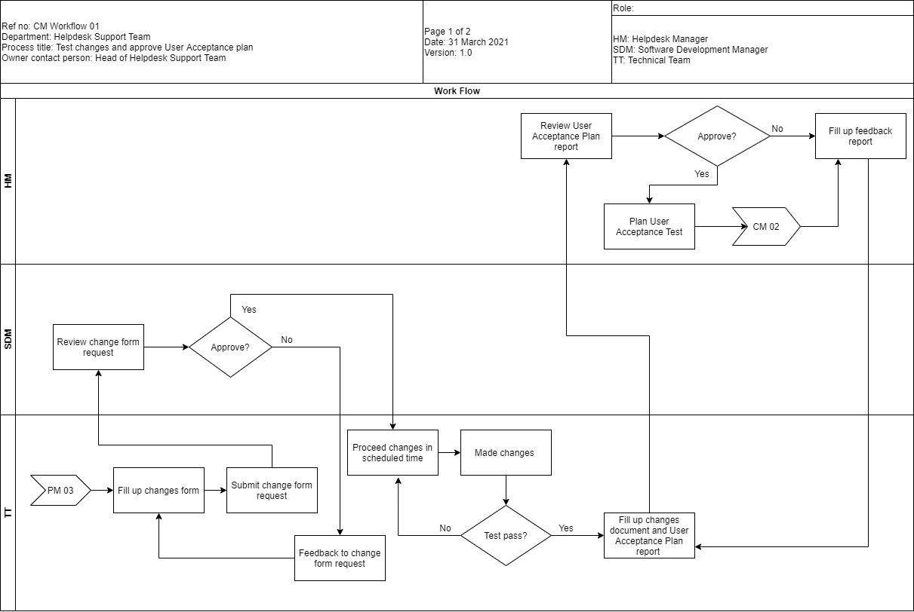

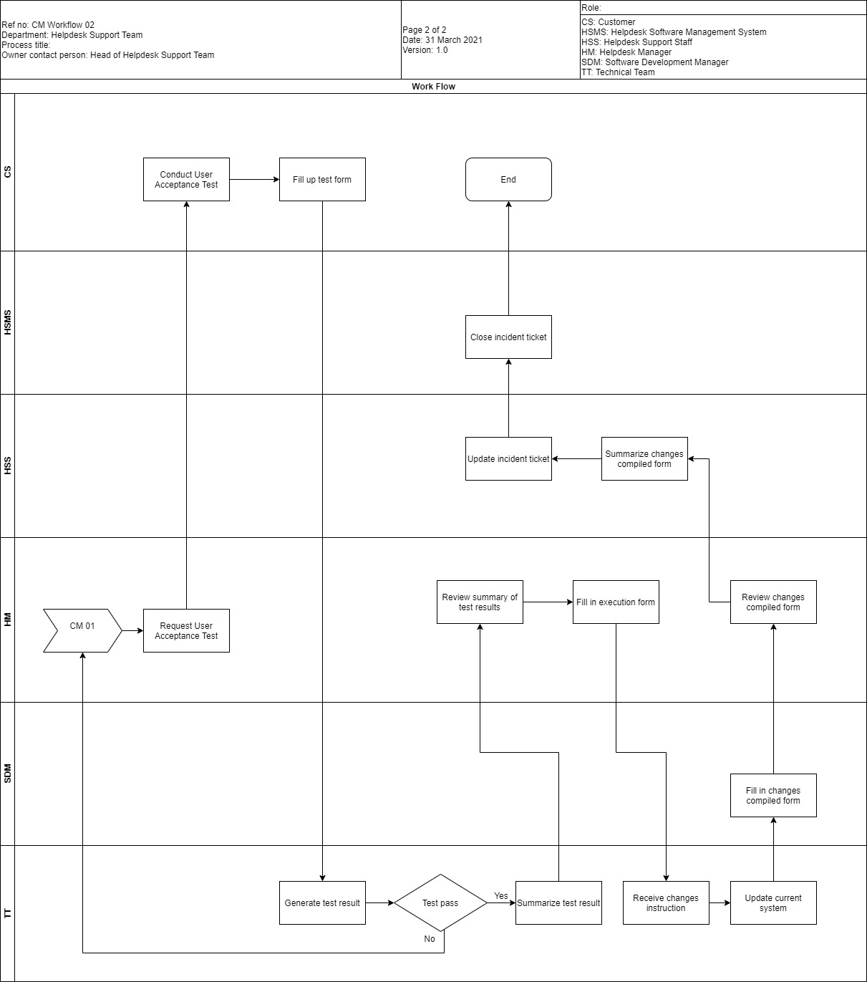

Policy

|  |  |  |  |
| --- | --- | --- | --- |
| **Software Company Name** | | | |
| Policy Title: **Change Management Policy** | | | |
| Policy Number: CMP-v001 | Rev No: 0 | Effective Date: 1 Jan 2022 | Page No:1 of 1 |

1. Purpose

This policy is to raise awareness and clearly understand the changes that proposed across the project or system affected. Furthermore, this policy has the main purpose of ensure that the changes are carried out in a better way to minimize the loss of clients’ faith on the company.

1. Scope

This policy applies to:

* All technical staff that involved in change management.
* All developers that involved in the development of specific system and project.
* Project and system change manager.
* All change requests to the company’s software product which includes minor, or major issues.

1. Responsibilities
   1. Change manager
      1. Responsible to monitor all of the change activities with the main objective of carrying out the changes as soon as possible.
      2. Approve and review the change form.
   2. Technical staff
      1. The staffs including developers and system testers, the staffs are using the expertise to carry out the system changes that specified by the clients to better version which reaching clients’ expectation.
2. Policy

* Change form with the details of changes is required to carry out any changes which includes minor or major changes to the system.
* The change from can be closed only when the client is satisfied with the changes that made to the system.
* Every change form must be approved and reviews by the change manager.
* Every change of the system must be tested and all of the details must be filled in the test cases.
* The test plan must be approved and reviewed by the superior of specific tester that carried out the software testing.

Standard

|  |  |  |  |
| --- | --- | --- | --- |
| **Software Company Name** | | | |
| Standard Title: **Change Management Standard** | | | |
| Standard Number: CMS-v001 | Rev No: 0 | Effective Date: 1 Jan 2022 | Page No:1 of 1 |

The standard of the change management is stated as below:

* The problem is a newly found defect and cannot be solved by both help desk support staff and problem management team.
* A change form is required to carry any changes that made to the system.
* Testing of the changed software and product must be carried out once the system has been changed.
* Test case must be created before carrying out any system testing.

Guideline

|  |  |  |  |
| --- | --- | --- | --- |
| **Software Company Name** | | | |
| Guideline Title: **Change Management Guideline** | | | |
| Guideline Number: CMG-v001 | Rev No: 0 | Effective Date: 1 Jan 2022 | Page No:1 of 1 |

1. After receiving the change form from the problem management team, the change management team will analyze and plan a system change or modification.
2. The plan will be submitted to the software development manager for approval.
   1. If the plan is approved, then the technical team will start to carry out the changes to the system.
   2. If the plan is declined, the reason and details will be given to the helpdesk support manager by the software development manager.
3. After the system is changed or modified, a test will be carried by the tester.
   1. If the test pass, a report of the changes made and the test plan as well as the test cases will be passed to the software development manager for review.
   2. If the test is not passed, the technical team will need to modify the system again.
4. After software development manager receiving the documentations,
   1. If approved, the system will be used to carry out user acceptance testing.
   2. If declined, the system needed to be modified again.
5. After the client receiving the system,
   1. If the user acceptance testing is passed and evaluated by the technical team, UAT report will be generated.
   2. If the user acceptance testing is failed, then the system will be modified again.
6. After the UAT report is generated, the technical team will apply the modifications that stated in the UAT report to the live system of the specific client.
7. A new patch will be released, and the software development manager will notify the help desk support manager about the system update after the approval.
8. Help desk support manager will record the latest patch into the system and provide the details of latest patch released to the help desk staff.
9. Help desk support staff will contact the related clients about the release of the latest patch.

Work instructions

|  |  |  |  |
| --- | --- | --- | --- |
| **Software Company Name** | | | |
| Work Instruction Title: **Change Management Work Instruction** | | | |
| Work Instruction Number: CMWI-v001 | Rev No: 0 | Effective Date: 1 Jan 2022 | Page No:1 of 1 |

1. Change issued – The change form is needed to be filled in when the problem management team could not solve the problem.
2. Change approval – The system change can be only approved by the change manager after the system change is completed.
3. UAT testing – The client that raised the issue will be involved in the testing to provide feedback on the satisfaction of the changed system.
4. Change closing – The change form will be closed when the client is satisfied with the new system.
5. Patch releasing – New patch will be included into the clients’ server and update.

**Part B1 B)**

1. **Incident Management Form Template**

**A) Incident Report Form**

|  |  |  |  |
| --- | --- | --- | --- |
| **Software Company Name** | | | |
| Form Title: **Incident Report Form** | | | |
| Form Number: IRF-v001 | Rev No: 0 | Effective Date: 1 Jan 2022 | Page No:1 of 1 |

Objective: The objective of this form is to record the necessary details of the occurred incident.

|  |  |
| --- | --- |
| **Section A: Incident Details** | |
| Incident ID: | Report Date: |
| Incident Date: | Severity:  Critical / Medium / Less Critical |
| Incident Duration: | Person Involved: |
| Description: | |
| Affected system’s functionality: | |
| **Prepared By:** | |
| Name:  Date:  _________________________  Signature | |
| **Approved by:** | |
| Name:  Date:  _________________________  Signature | |

**B) Incident Damage Form**

|  |  |  |  |
| --- | --- | --- | --- |
| **Software Company Name** | | | |
| Form Title: **Incident Damage Form** | | | |
| Form Number: IDF-v001 | Rev No: 0 | Effective Date: 1 Jan 2022 | Page No:1 of 1 |

Objective: The objective of this form is to record down the damage that is inflicted during the occurrence of incident.

|  |  |
| --- | --- |
| **Section A: Damage Details** | |
| Incident Damage ID: | Incident ID Reference: |
| System Status: | |
| Affected System/Features: | |
| **Section B: Technical Details** | |
| Operating System: | System Version: |
| **Prepared By:** | |
| Name:  Date:  _________________________  Signature | |
| **Approved by:** | |
| Name:  Date:  _________________________  Signature | |

**C) Post Incident Review Form**

|  |  |  |  |
| --- | --- | --- | --- |
| **Software Company Name** | | | |
| Form Title: **Post Incident Review Form** | | | |
| Form Number: PIRF-v001 | Rev No: 0 | Effective Date: 1 Jan 2022 | Page No:1 of 1 |

Objective: The objective of this form is to track and review the incident occurred and ensure the incident is solved and accepted by the customer.

|  |  |
| --- | --- |
| **Section A: Post Incident Review Details:** | |
| Post Incident ID: | Date Created: |
| Incident ID Reference: | Status:  (Solved / Unsolved) |
| Post Incident Description: | |
| Resolution Duration: | Customer Satisfaction Point:  1/2/3/4/5 |
| Customer Feedback: | |
| **Prepared By:** | |
| Name:  Date:  _________________________  Signature | |
| **Approved by:** | |
| Name:  Date:  _________________________  Signature | |

1. **Problem Management Form Template**

**A) Problem Causal Form**

|  |  |  |  |
| --- | --- | --- | --- |
| **Software Company Name** | | | |
| Form Title: **Problem Causal Form** | | | |
| Form Number: PCF-v001 | Rev No: 0 | Effective Date: 1 Jan 2022 | Page No:1 of 1 |

Objective: The objective of this form is to record the causal of the problem to understand the problem

|  |  |  |
| --- | --- | --- |
| **Section A: Problem Causal Details:** | | |
| Problem Causal ID: | Date Created: | |
| Problem Description: | | |
| Root Cause: | | |
| **Section B: Affected Entity** | | |
| Project Name: | | Version: |
| Affected Files: | | |
| **Prepared By:** | | |
| Name:  Date:  _________________________  Signature | | |
| **Approved by:** | | |
| Name:  Date:  _________________________  Signature | | |

**B) Problem Resolution Form**

|  |  |  |  |
| --- | --- | --- | --- |
| **Software Company Name** | | | |
| Form Title: **Problem Resolution Form** | | | |
| Form Number: PRF-v001 | Rev No: 0 | Effective Date: 1 Jan 2022 | Page No:1 of 1 |

Objective: The objective of this form is to provide a proposal to solve the problem.

|  |  |  |
| --- | --- | --- |
| **Section A: Problem Resolution Details:** | | |
| Problem Resolution ID: | Date Created: | |
| Summary of proposed solution: | | |
| Solution: | | |
| **Section B: Affected Entity** | | |
| Project Name: | | Version: |
| Affected Files: | | |
| **Prepared By:** | | |
| Name:  Date:  _________________________  Signature | | |
| **Approved by:** | | |
| Name:  Date:  _________________________  Signature | | |

1. **Change Management Form Template**

**A) Modification Request Form**

|  |  |  |  |
| --- | --- | --- | --- |
| **Software Company Name** | | | |
| Form Title: **Modification Request Form** | | | |
| Form Number: MRF-v001 | Rev No: 0 | Effective Date: 1 Jan 2022 | Page No:1 of 1 |

Objective: The objective of this form is to record the changes that is being made so that the affected entity can be traced.

|  |  |  |  |
| --- | --- | --- | --- |
| **Section A: Modification Request Details:** | | | |
| Modification Request ID: | | | Date Created: |
| Entity Affected: | | | Incident ID Reference: |
| Modification Description: | | | |
| Duration to complete: | | Level of Impact: (High / Medium / Low) | |
| Impact after Modification is Made: | | | |
| **Section B: Affected Entity** | | | |
| Project Name: | Version: | | |
| Affected Files: | | | |
| **Prepared By:** | | | |
| Name:  Date:  _________________________  Signature | | | |
| **Approved by:** | | | |
| Name:  Date:  _________________________  Signature | | | |

**B) Modification Testing Form**

|  |  |  |  |
| --- | --- | --- | --- |
| **Software Company Name** | | | |
| Form Title: **Modification Testing Form** | | | |
| Form Number: MTF-v001 | Rev No: 0 | Effective Date: 1 Jan 2022 | Page No:1 of 1 |

Objective: The objective of this form is to record the testing of the modification that is being made on the selective entity

|  |  |
| --- | --- |
| **Section A: Modification Testing Details** | |
| Modification Test ID: | Modification Request Reference ID: |
| Test By: | Version: |
| **Section B: Test Analysis** | |
| Test Module Name: | Test Date: |
| Priority: High / Medium / Low | |
| Pre-Requisites: | Post-Conditions: |
| Test Steps: | |
| Expected Result: | |
| Actual Result: | |
| Test Summary: | |
| **Prepared By:** | |
| Name:  Date:  _________________________  Signature | |
| **Approved by:** | |
| Name:  Date:  _________________________  Signature | |

**Part B2 A)**

1. **Bug Fix Handling Workflow**

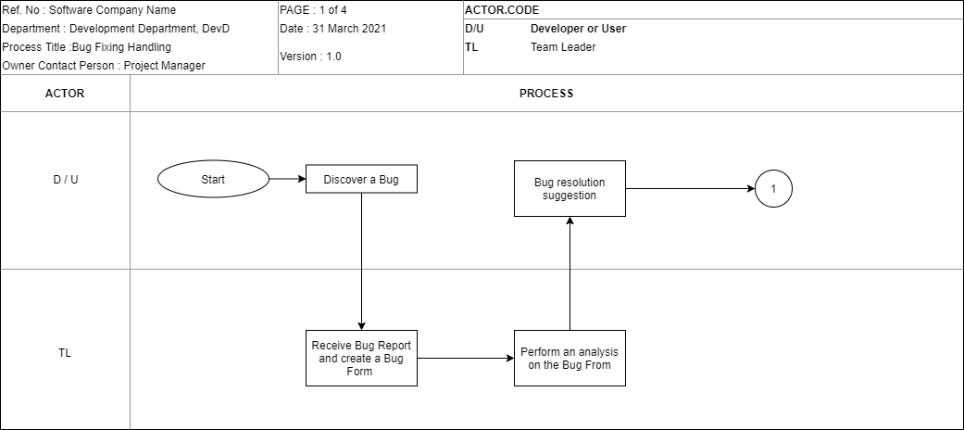

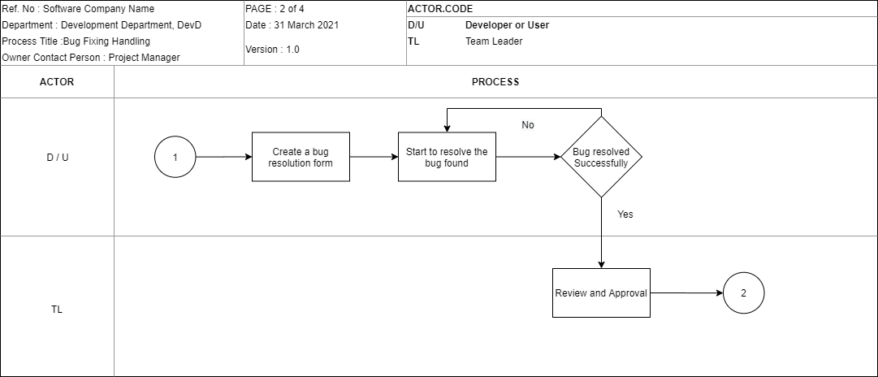

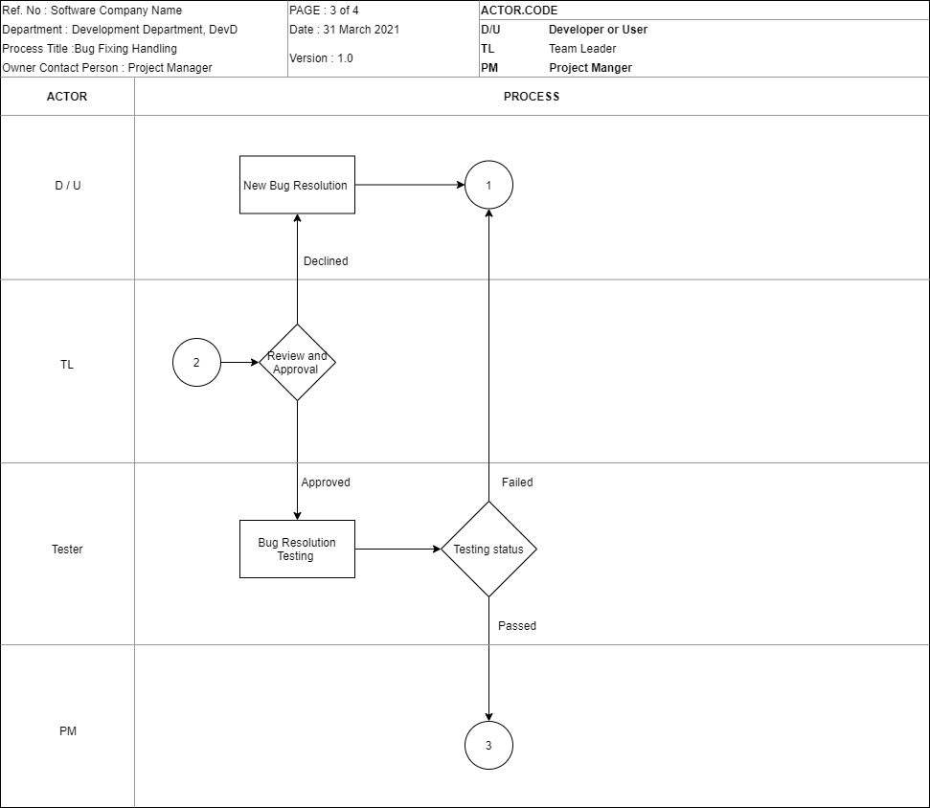

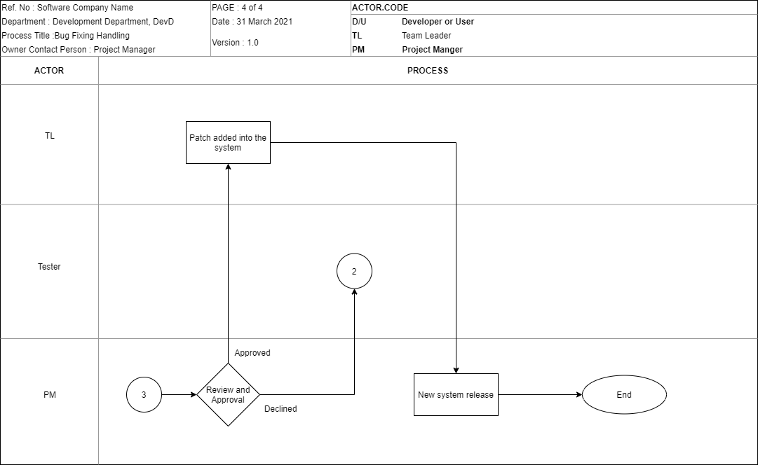

**Policy**

|  |  |  |  |
| --- | --- | --- | --- |
| **Software Company Name** | | | |
| Policy Title: **Bug Fix Handling Policy** | | | |
| Policy Number: BFHP-v001 | Rev No: 0 | Effective Date: 1 Jan 2022 | Page No:1 of 1 |

The policy is the high-level statement for bug fixing which must be referred by the development team members, and other personnel who involved in bug fixing.

* Bug report form must be filled in immediately when a defect is found.
* Bug report form will be passed to the bug fixing staff and the specific staff will start to carry out the bug fixing.
* Bug resolution form must be created once the bug fixing starts.
* Bug resolution form is required to reviewed and approved by the superiors.
* Penalty will be given according to the failure resulted by any personnel.

**Standard**

|  |  |  |  |
| --- | --- | --- | --- |
| **Software Company Name** | | | |
| Standard Title: **Bug Fix Handling Standard** | | | |
| Standard Number: BFHS-v001 | Rev No: 0 | Effective Date: 1 Jan 2022 | Page No:1 of 1 |

This standard is only applicable for the personnel who involved in the bug fixing and it has the main objective of achieving the customers’ satisfaction.

* The bug reported must be a newly found defect from the system.
* After the bug report form is completed, the bug resolution must be carried out immediately with the support document of bug resolution form.
* Bug resolution form must include all the details of the resolution and needed to be reviewed and approved by the superior of the specific assignee.
* The bug resolution form has to be passed to testing team after approved by the superior.

**Guideline**

|  |  |  |  |
| --- | --- | --- | --- |
| **Software Company Name** | | | |
| Guideline Title: **Bug Fix Handling Guideline** | | | |
| Guideline Number: BFHG-v001 | Rev No: 0 | Effective Date: 1 Jan 2022 | Page No:1 of 1 |

1. Bug report form must be filled in once the bug is reported or found.
2. The severity of the bug must be clearly stated in the form for the bug fixing priority.
3. System changing and testing must be carried out once the workaround is completed.
4. The project manager must review and approve the bug fix to authenticate all of the activities have been carried out.

**Procedure**

|  |  |  |  |
| --- | --- | --- | --- |
| **Software Company Name** | | | |
| Procedure Title: **Bug Fix Handling Procedure** | | | |
| Procedure Number: BFHPro-v001 | Rev No: 0 | Effective Date: 1 Jan 2022 | Page No:1 of 1 |

* 1. Bug reporting form will be created when a new bug is found from the system.
  2. After the bug form is created, bug resolution will be carried out and bug resolution form will be created.
     1. If the bug is solved, the bug resolution form will be passed to superior for review and approval.
     2. If the bug is not solved, the specific assignee will need to carry out the bug resolution again.
  3. After the superior has the bug resolution form,
     1. If the superior approved the bug resolution, the form will be passed to testing team for software testing.
     2. If the supervisor declined the bug resolution, the form will be passed back to the assignee and the specific assignee need to figure out another bug resolution.
  4. After completion of the testing, the bug resolution form will be passed to project manager for review and approval.
     1. If the project manager approved, then new patch will be released.
     2. If the project manager declined, then the testing will be carried out again.

**Work Instruction**

|  |  |  |  |
| --- | --- | --- | --- |
| **Software Company Name** | | | |
| Work Instruction Title: **Bug Fix Handling Work Instruction** | | | |
| Work Instruction Number: BFHWI-v001 | Rev No: 0 | Effective Date: 1 Jan 2022 | Page No:1 of 1 |

* 1. Bug Reporting – The reporting of bug must be a newly founded bug.
  2. Bug Resolution – The resolution time must be referring to the manual resolution time part which describing the severity and the resolution time.

1. **Testing Handling Workflow**

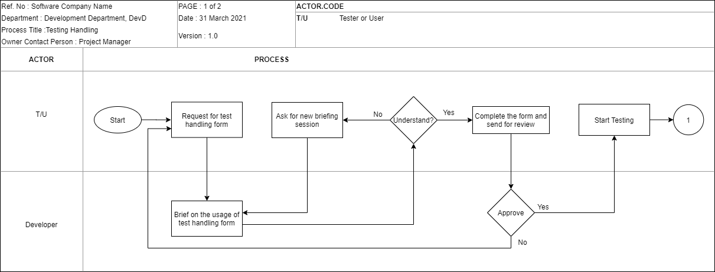

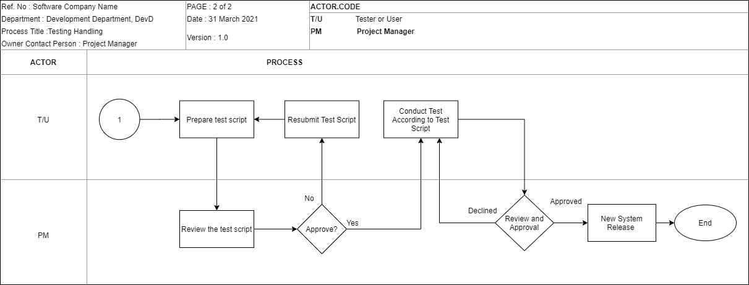

**Policy**

|  |  |  |  |
| --- | --- | --- | --- |
| **Software Company Name** | | | |
| Policy Title: **Testing Handling Policy** | | | |
| Policy Number: THP-v001 | Rev No: 0 | Effective Date: 1 Jan 2022 | Page No:1 of 1 |

* + This policy is applied to any personnel who involved in the testing activities.
  + Testing must be carried out whenever a change to the system is made to ensure that the requirement is met.
  + Test case or the test form must be created once the system change has been notified.
  + A test case must be reviewed and approved by the superior before closing it.
  + After the test case has been closed, a software release note will be created.

**Standard**

|  |  |  |  |
| --- | --- | --- | --- |
| **Software Company Name** | | | |
| Standard Title: **Testing Handling Standard** | | | |
| Standard Number: THS-v001 | Rev No: 0 | Effective Date: 1 Jan 2022 | Page No:1 of 1 |

* Test case can be only created if the system has been changed and issued by the development team.
* The pre-requisites of all the test form must be completed before carrying out any of the testing.
* All of the testing standard should be referring to ISO 9001: 2019.
* After completion of testing, review and approval from the superior is a must.

**Guideline**

|  |  |  |  |
| --- | --- | --- | --- |
| **Software Company Name** | | | |
| Standard Title: **Testing Handling Guideline** | | | |
| Standard Number: THG-v001 | Rev No: 0 | Effective Date: 1 Jan 2022 | Page No:1 of 1 |

1. A test form must be created before the testing starts due to the pre-requisite is a must to complete first before the testing.
2. Test script should be created when the test starts, which needed to be filled in the steps and details of the test.
3. Project manager review and approval is a must before release the latest system.

**Procedure**

|  |  |  |  |
| --- | --- | --- | --- |
| **Software Company Name** | | | |
| Procedure Title: **Testing Handling Procedure** | | | |
| Procedure Number: THPro-v001 | Rev No: 0 | Effective Date: 1 Jan 2022 | Page No:1 of 1 |

1. Once the tester receives any notification of the system change, a test form should be ready and start to carry out the test.
2. According to the test form there will be the expected and actual result.
   1. If both of the results are match then the test is considered as pass.
   2. If the expected and actual doesn’t match then the test has failed.
3. Once the evaluation has completed,
   1. If the test passes, the test form will be passed to the superior for review and approval.
   2. If the test failed, the form will be passed back to the developer and solve the problem again.
4. After the superior review the test form,
   1. If the superior approves the test form, a release note will be created.
   2. If the superior declines the test form, the test form will be passed back to the tester for testing again.
5. **Software Release Handling Workflow**

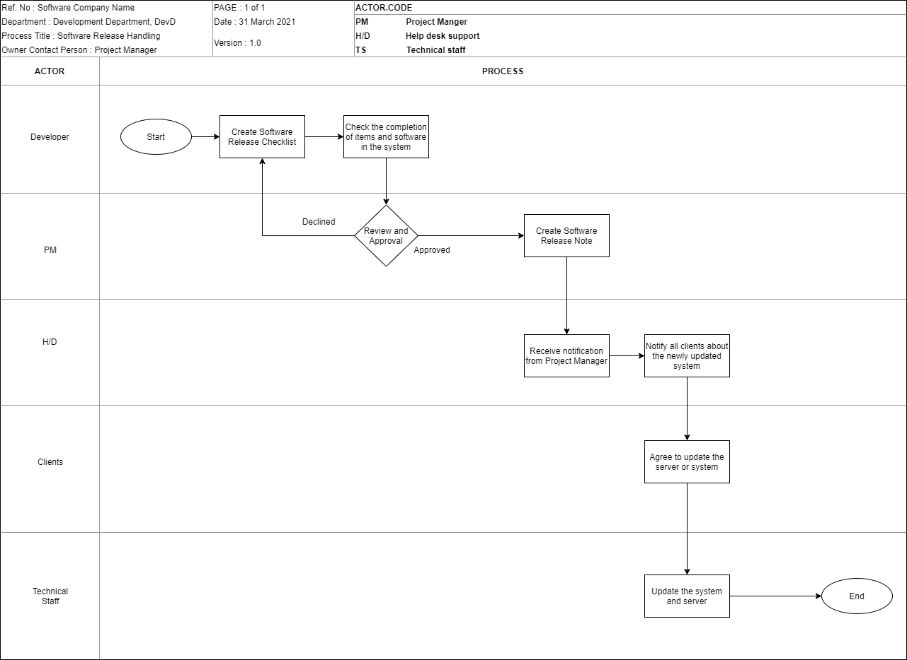

**Policy**

|  |  |  |  |
| --- | --- | --- | --- |
| **Software Company Name** | | | |
| Policy Title: **Software Release Handling Policy** | | | |
| Policy Number: SRHP-v001 | Rev No: 0 | Effective Date: 1 Jan 2022 | Page No:1 of 1 |

* Software release note will be created when the system updated to a newer version.
* Software release note must be clear and understandable since it will be read by the end-users.

**Standard**

|  |  |  |  |
| --- | --- | --- | --- |
| **Software Company Name** | | | |
| Standard Title: **Software Release Handling Standard** | | | |
| Standard Number: SRHS-v001 | Rev No: 0 | Effective Date: 1 Jan 2022 | Page No:1 of 1 |

* Software release can be created only when the test case from the new updated system is reviewed and approved by the superiors.
* A read me test file should be included into the system update file package which will be released to the clients.
* Inside the read me text file, not only the patch, fixes or new features must be included, the procedure to install the latest system must be also included.
* Help desk support staff have the responsibility to notify the clients about the latest system update release.

**Guideline**

|  |  |  |  |
| --- | --- | --- | --- |
| **Software Company Name** | | | |
| Guideline Title: **Software Release Handling Guideline** | | | |
| Guideline Number: SRHG-v001 | Rev No: 0 | Effective Date: 1 Jan 2022 | Page No:1 of 1 |

1. Software release checklist will be created once the new system is approved by the project manager.
2. The software release checklist must be used to check all of the items and software of the system must be included into the latest system.
3. The helpdesk support staff must notify the clients by sending the software release notes.

**Procedure**

|  |  |  |  |
| --- | --- | --- | --- |
| **Software Company Name** | | | |
| Procedure Title: **Software Release Handling Procedure** | | | |
| Procedure Number: SRHPro-v001 | Rev No: 0 | Effective Date: 1 Jan 2022 | Page No:1 of 1 |

1. After reviewed and approved by the project manager from the test, the system can be considered as completed.
2. The software release checklist will be created to ensure all of the items has been included into the system.
3. Once the checklist is completely checked, a new software release note will be created.
4. The software release note will be distributed to the help desk support staff for notifying the clients about the latest version of the system.
5. After the clients agreed to update to the latest system, the technical team will implement the system into the clients’ server.
6. **Lesson Learnt Workflow**

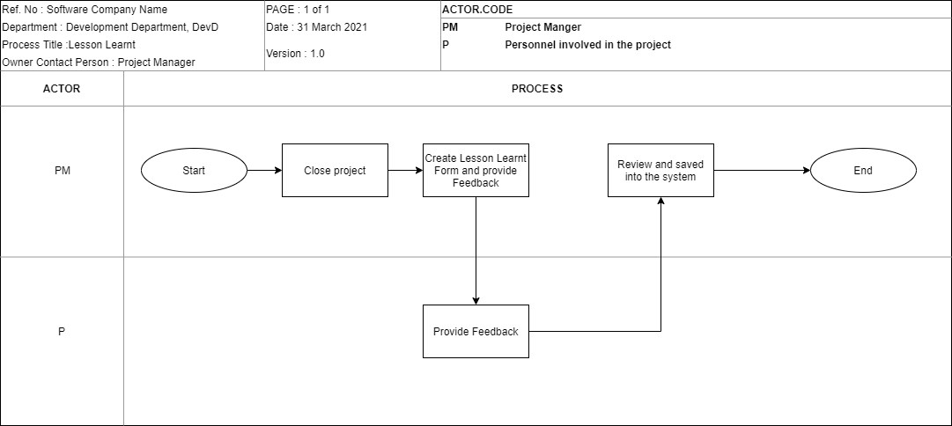

**Policy**

|  |  |  |  |
| --- | --- | --- | --- |
| **Software Company Name** | | | |
| Policy Title: **Lesson Learnt Policy** | | | |
| Policy Number: LLP-v001 | Rev No: 0 | Effective Date: 1 Jan 2022 | Page No:1 of 1 |

* The lesson learnt report is a must for the employee to learn mistake from the past project.
* The lesson learnt report must be created only the system has been closed.
* All of the personnel involved in the whole development process must provide a feedback to the project.

**Standard**

|  |  |  |  |
| --- | --- | --- | --- |
| **Software Company Name** | | | |
| Standard Title: **Lesson Learnt Standard** | | | |
| Standard Number: LLS-v001 | Rev No: 0 | Effective Date: 1 Jan 2022 | Page No:1 of 1 |

* Once the project is closed, the lesson learnt report is required immediately.
* The personnel that involved in the project are required to provide feedback, especially the higher-level manager.

**Procedure**

|  |  |  |  |
| --- | --- | --- | --- |
| **Software Company Name** | | | |
| Procedure Title: **Lesson Learnt Procedure** | | | |
| Procedure Number: LLPro-v001 | Rev No: 0 | Effective Date: 1 Jan 2022 | Page No:1 of 1 |

1. Once the project is closed by the project manager, a lesson learnt report will be created.
2. After the project manager providing feedback, the personnel involved in the project are required to provide lesson learnt into the form.
3. The form will be reviewed by the project manager and it will be saved into the system as a reference for the next similar project.

**Part B2 B)**

1. **Bug Fix Handling Form Template**
   1. Bug Report Form

|  |  |  |  |
| --- | --- | --- | --- |
| **Software Company Name** | | | |
| Form Title: **Bug Report Form** | | | |
| Form Number: BRF-v001 | Rev No: 0 | Effective Date: 1 Jan 2022 | Page No:1 of 1 |

Objective: This form is used to record down every detail of the bug found.

|  |  |
| --- | --- |
| **Section A: Bug Details** | |
| Bug ID: | Report Date: |
| Date of Bug Found: | Version: |
| Severity: Critical / Normal / Less Critical | |
| Description: | |
| Affected system’s functionality: | |
| **Prepared By:** | |
| Name:  Date:  _________________________  Signature | |

* 1. Bug Resolution Form

|  |  |  |  |
| --- | --- | --- | --- |
| **Software Company Name** | | | |
| Form Title: **Bug Resolution Form** | | | |
| Form Number: BResF-v001 | Rev No: 0 | Effective Date: 1 Jan 2022 | Page No:1 of 1 |

Objective: The objective of this form is to record down the resolution for the specific bug.

|  |  |  |
| --- | --- | --- |
| **Section A: Bug Resolution Details:** | | |
| Bug Resolution ID: | Date Created: | |
| Summary of proposed solution: | | |
| Solution: | | |
| **Section B: Affected Entity** | | |
| Project Name: | | Version: |
| Affected Files: | | |
| **Prepared By:** | | |
| Name:  Date:  _________________________  Signature | | |
| **Approved by:** | | |
| Name:  Date:  _________________________  Signature | | |

1. **Testing Handling Form Template**
   1. Test Form

|  |  |  |  |
| --- | --- | --- | --- |
| **Software Company Name** | | | |
| Form Title: **Test Form** | | | |
| Form Number: TF-v001 | Rev No: 0 | Effective Date: 1 Jan 2022 | Page No:1 of 1 |

Objective: The objective of this form is to record the testing that is being made on the selective entity.

|  |  |
| --- | --- |
| **Section A: Testing Details** | |
| Test Form ID: | Bug Resolution Reference ID: |
| Test By: | Version: |
| **Section B: Test Analysis** | |
| Test Module Name: | Test Date: |
| Priority: High / Medium / Low | |
| Pre-Requisites: | Post-Conditions: |
| Test Steps: | |
| Expected Result: | |
| Actual Result: | |
| Test Summary: | |
| **Prepared By:** | |
| Name:  Date:  _________________________  Signature | |
| **Approved By:** | |
| Name:  Date:  _________________________  Signature | |

* 1. Test Script

|  |  |  |  |
| --- | --- | --- | --- |
| **Software Company Name** | | | |
| Form Title: **Test Script** | | | |
| Form Number: TS-v001 | Rev No: 0 | Effective Date: 1 Jan 2022 | Page No:1 of 1 |

Objective: This form is used to describe the information that should be carried out under a test

|  |  |
| --- | --- |
| **Section A: Test Script Details** | |
| Test Script ID: | Date of Test: |
| Test By: | Version: |
| **Section B: Test Script Description** | |
| Test Form Reference ID: | |
| Purpose of Test: | |
| Test Environment: | |
| Test Steps: | |
| Expected Result: | |
| **Prepared By:** | |
| Name:  Date:  _________________________  Signature | |
| **Approved By:** | |
| Name:  Date:  _________________________  Signature | |

1. **Software Release Handling Form Template**
   1. Software Release Checklist

|  |  |  |  |
| --- | --- | --- | --- |
| **Software Company Name** | | | |
| Form Title: **Software Release Checklist** | | | |
| Form Number: SRC-v001 | Rev No: 0 | Effective Date: 1 Jan 2022 | Page No:1 of 1 |

Objective: This form is used to check the activities to be done during the new software update release.

|  |  |  |
| --- | --- | --- |
| **Section A: Software Release Checklist Details** | | |
| Software Release Checklist ID: | Date: | |
| Version: | Project: | |
| **Section B: Software Release Checklist Activities** | | |
| Activities / Items | Completed / Not completed | Comments |
|  |  |  |
|  |  |  |
|  |  |  |
|  |  |  |
|  |  |  |
|  |  |  |
|  |  |  |
| **Reviewed by:** | | |
| Name:  Date:  _________________________  Signature | | |

* 1. Software Release Form

|  |  |  |  |
| --- | --- | --- | --- |
| **Software Company Name** | | | |
| Form Title: **Software Release Form** | | | |
| Form Number: SRF-v001 | Rev No: 0 | Effective Date: 1 Jan 2022 | Page No:1 of 1 |

Objective: This form is used whenever the new software updates, patches and fixes are added into the system.

|  |  |  |  |
| --- | --- | --- | --- |
| **Section A: Software Release Details** | | | |
| Software Release Form ID: | Date of Release: | | |
| Version: | Software Release Checklist Reference ID: | | |
| Release Description: | | | |
| **Section B: Software / Items Affected** | | | |
| Software / Items | Descriptions | History | Version |
|  |  |  |  |
|  |  |  |  |
|  |  |  |  |
|  |  |  |  |
| **Prepared By:** | | | |
| Name:  Date:  _________________________  Signature | | | |
| **Reviewed by:** | | | |
| Name:  Date:  _________________________  Signature | | | |
| **Approved by:** | | | |
| Name:  Date:  _________________________  Signature | | | |

1. **Lesson Learnt Form Template**
   1. Lesson Learnt Form

|  |  |  |  |
| --- | --- | --- | --- |
| **Software Company Name** | | | |
| Form Title: **Lesson Learnt Form** | | | |
| Form Number: LLF-v001 | Rev No: 0 | Effective Date: 1 Jan 2022 | Page No:1 of 1 |

Objective: This form is used to document the feedback of all feedbacks from the personnel who involved in the development.

|  |  |  |  |
| --- | --- | --- | --- |
| **Section A: Lesson Learnt Details** | | | |
| Lesson Learnt ID: | Date: | | |
| Project: | | | |
| Project Start Date: | | Project End Date: | |
| **Section B: Feedbacks** | | | |
| Name | Position | | Feedback |
|  |  | |  |
|  |  | |  |
|  |  | |  |
|  |  | |  |
|  |  | |  |
| **Reviewed by:** | | | |
| Name:  Date:  _________________________  Signature | | | |

**REFERENCE DOCUMENT**

Checklist Template.

Retrieved From:

https://hookedoninnovation.com/2012/09/05/ipad-deployment-checklist-for-k-12/

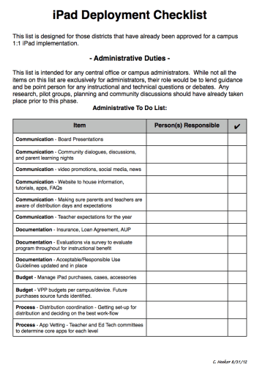

Test Case Template.

Retrieved From: <https://www.softwaretestinghelp.com/test-case-template-examples/>

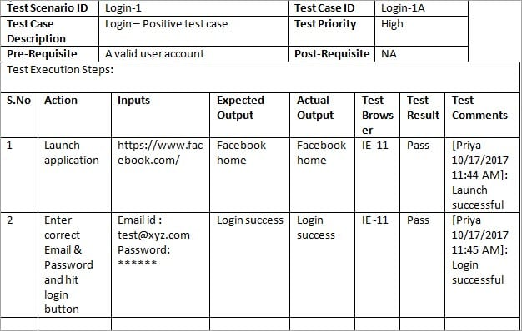

Sign-Off Form Template.

Retrieved from: <https://filestage.io/blog/sign-off-sheet/>

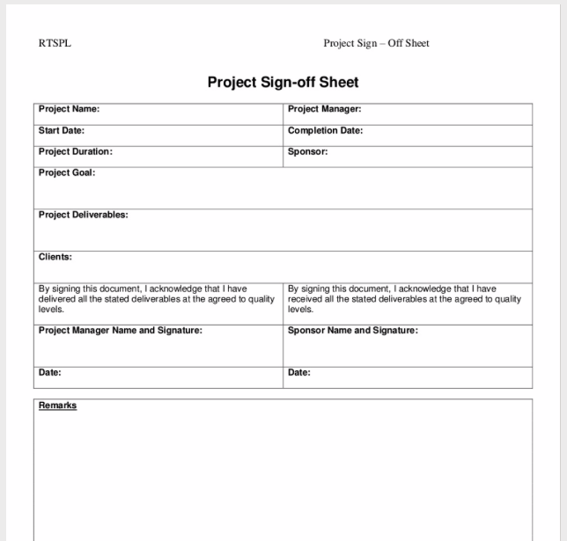

***(Source: StudyLib)***

**Assignment Submission Checklist**

* **Cover Page (Provided by the lecturer, WBLE)**
* Part A ( A1 & A2 )
* Part B ( B1 & B2 )
* Title Page
* Table of Content
* Reference Document (**MUST have**)
* **Via WBLE (Part A and Part B)**